Directory and development Introduce

Introduce File Name：Directory and development Introduce
Introduce File No.：
Version ：V1.0

Total 7 pages
(Including cover)

Compose ZhangYong
Review
Countersign

Cilico Microelectronics Co., Ltd
Modifiy record
File No. | Version | Composed By / Modified By | Compose / Modify Date | Modify Reason | Major changes  （Write main Points） | Review By
 | V1.0 | ZhangYong | 2017.03.27 | None | None | ShiLiangYi
Note: When the file is prepared for the first time, write “None” on "Modify Reason" and "Major modifications columns.

Contents

1. Purpose 4
2. Applicable Scope 4
3. Content 4
3.1 Print App UseManual 4
3.2 API Introduce 4
3.3 APK 4
3.4 SourceCode 4
4. Development Introduce 4
4.1 Create project 4
4.2 Integrated Tools Class 4
4.3 Call Print API 5
4.4 Parse Card Info 6
4.5 printer Introduce 7

1 Pursose
The introduction of each directory and the secondary development steps.

2 Applicable scope
Adapter to PDA ,which supports print function.

3 Content
3.1 Print App UseManual File
The file path is“\print\UserManual\”，Which contains two documents in Chinese and English, by learning this document, you can quickly learn how to use Print APP to print information.
3.2 API Introduce File
The file path is“\print\APIDocument\”，Which contains two documents in Chinese and English, by learning this document, you can understand how to correct use each method.
3.3 Apk
The file path is“\print\Apk\”。
3.4 SourceCode
The file path is“\print\SourceCode\”。

4 Development introduce
4.1 Create Project
Create a new Android studio project which name is TestPrint.
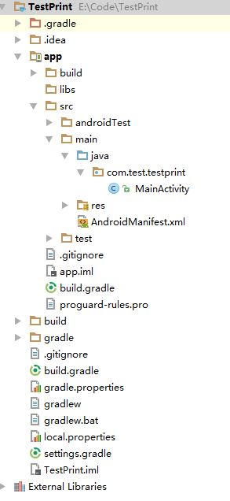
4.2 Integrated Tools Classes
Copy the following three files to the project home directory.
\print\SourceCode\PrintChecker\app\src\main\java\hardware\print\BarcodeUtil.java
\print\SourceCode\PrintChecker\app\src\main\java\hardware\print\printer.java
Copy the following three library files to the project home directory.
\print\SourceCode\PrintChecker\app\libs\armeabi\libhardware-print.so
\print\SourceCode\PrintChecker\app\libs\core-2.3.0.jar
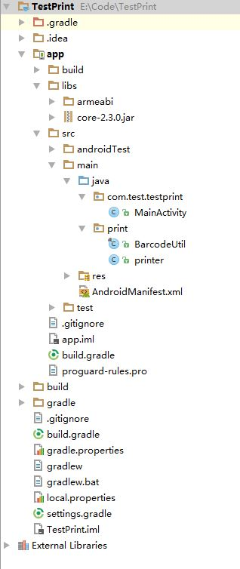
4.3 Call print API
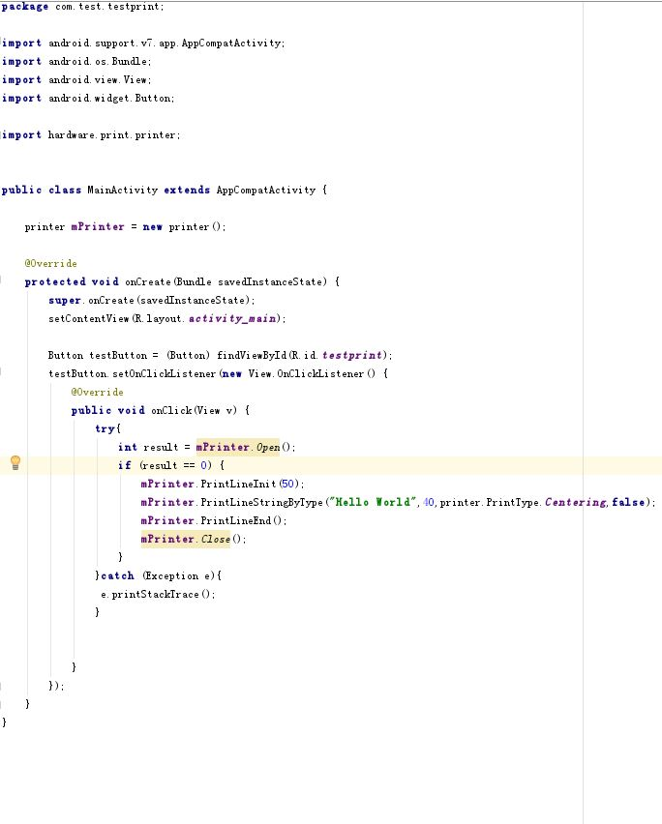
4.4 printer Introduce
The printer class contains more ways to operate the card, review the following file：
\print\APIDocument\Introduction of Print API.doc

